**Министерство науки и высшего образования Российской Федерации**

федеральное государственное автономное образовательное учреждение

высшего образования

**«НАЦИОНАЛЬНЫЙ ИССЛЕДОВАТЕЛЬСКИЙ**

**ТОМСКИЙ ПОЛИТЕХНИЧЕСКИЙ УНИВЕРСИТЕТ»**

Инженерная школа природных ресурсов

Направление подготовки Химическая технология

Отделение химической инженерии

**ЧИСЛЕННЫЕ МЕТОДЫ РЕШЕНИЯ СИСТЕМ ОБЫКНОВЕННЫХ ДИФФЕРЕНЦИАЛЬНЫХ УРАВНЕНИЙ**

**Лабораторная работа по дисциплине «Углубленный курс информатики»**

Выполнил студент гр. 2Д93 К.Ю. Мельников

(Подпись)

_____ _____________ 2020 г.

Отчет принят:

Преподаватель

доцент ОХИ ИШПР, к.т.н. В.А. Чузлов

(Подпись)

_____ _____________ 2020 г.

Томск 2020 г.

**Цель работы:** изучить и использовать метод Эйлера и Рунге-Кутты для решения обыкновенных дифференциальных уравнений.

**Теоретическая часть**

Пусть дано дифференциальное уравнение:

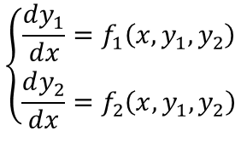

с начальными условиями:

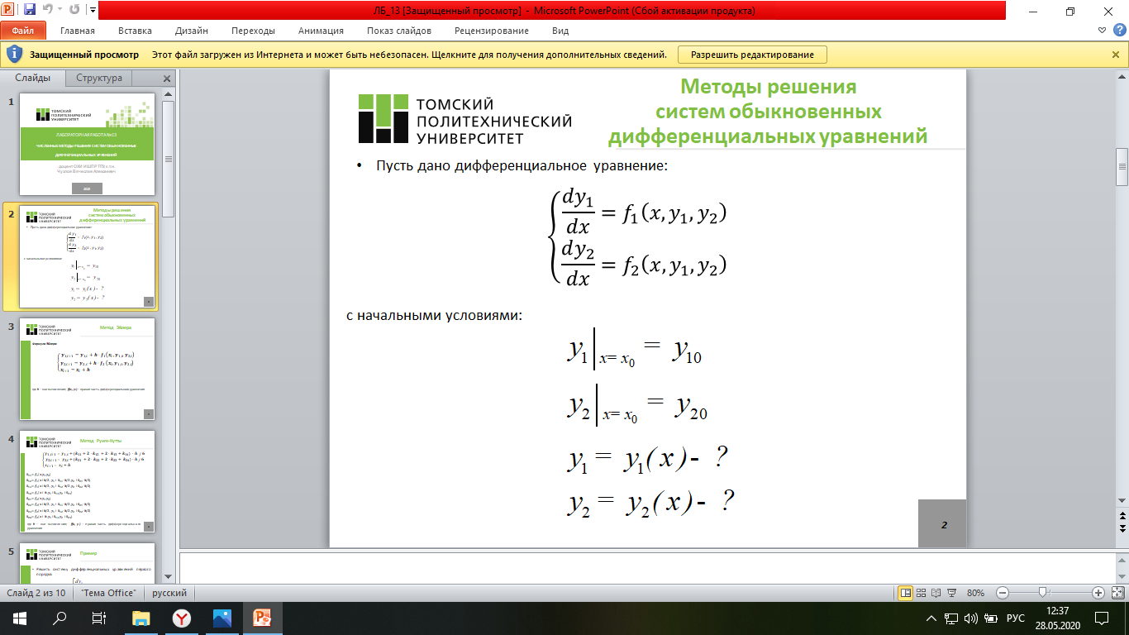

Метод Эйлера

Пусть дано дифференциальное уравнение:

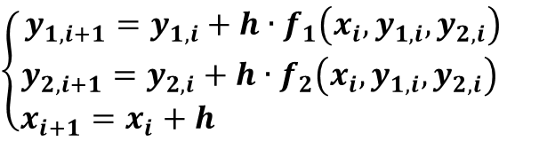

где h – шаг вычисления; f(xi, yi) – правая часть дифференциального уравнения

Метод Рунге-Кутты

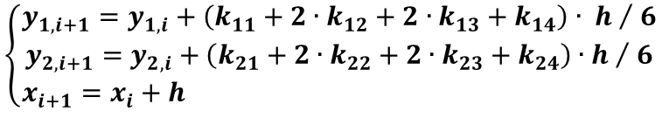

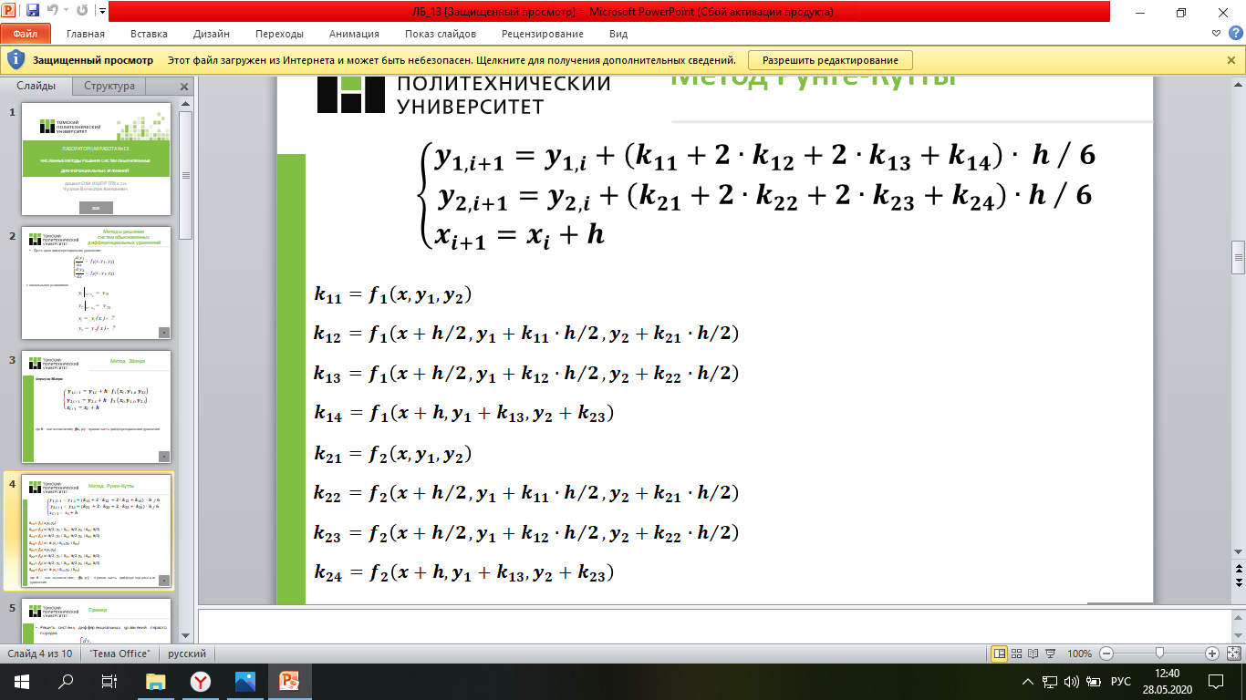

где h – шаг вычисления; f(x, y) – правая часть дифференциального уравнения

**Практическая часть**

**Задание 1**

**Задание:** решите систему дифференциальных уравнений методами Эйлера и Рунге-Кутты. Определите погрешность расчетного значения переменной y для каждого из методов, использовав формулу:

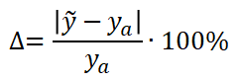

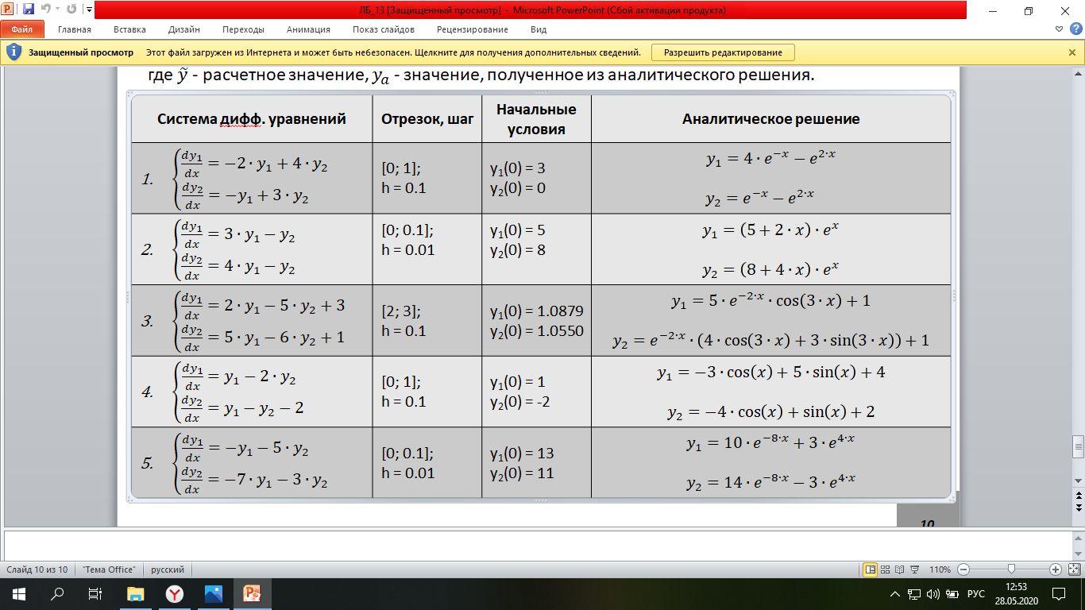

**Программная реализация**

1) Метод Эйлера

program L13_1_1;

type

matrix = array of array of real;

arr = array of real;

function right_parts(x, y1, y2: real): arr;

begin

SetLength(result, 2);

result[0] := -2*y1+4*y2;

result[1] := -y1+3*y2;

end;

function eyler_method(start_x, stop_x, h, start_y1, start_y2: real): matrix;

var

i: integer;

x, y1, y2, dy1, dy2, ya1, ya2: real;

f: arr;

begin

SetLength(result, Trunc((stop_x - start_x) / h) + 1);

for i := 0 to High(result) do

SetLength(result[i], 7);

x := start_x;

y1 := start_y1;

y2 := start_y2;

for i := 0 to High(result) do

begin

result[i, 0] := x;

result[i, 1] := y1;

result[i, 2] := y2;

result[i, 3] := ya1;

result[i, 4] := ya2;

result[i, 5] := dy1;

result[i, 6] := dy2;

f := right_parts(x, y1, y2);

y1 := y1 + h * f[0];

y2 := y2 + h * f[1];

x := x + h;

ya1 := 4*exp(-x)-exp(2*x);

ya2 := exp(-x)-exp(2*x);

dy1 := abs((y1-ya1)/(ya1))*100;

dy2 := abs((y2-ya2)/(ya2))*100

end;

end;

procedure print_results(res: matrix);

var

i, j: integer;

begin

for i := 0 to High(res) do

begin

for j := 0 to High(res[i]) do

write(res[i, j]:10:4);

writeln

end;

end;

begin

writeln('Х':8,'Y1':10,'Y2':11,'Y1a':10,'Y2a':9,'dY1':11,'dY2':10);

print_results(eyler_method(0, 1, 0.1, 3, 0))

end.

**Ответ**

Х Y1 Y2 Y1a Y2a dY1 dY2

0.0000 3.0000 0.0000 0.0000 0.0000 0.0000 0.0000

0.1000 2.4000 -0.3000 2.3979 -0.3166 0.0856 5.2328

0.2000 1.8000 -0.6300 1.7831 -0.6731 0.9479 6.4024

0.3000 1.1880 -0.9990 1.1412 -1.0813 4.1051 7.6113

0.4000 0.5508 -1.4175 0.4557 -1.5552 20.8586 8.8554

0.5000 -0.1264 -1.8978 -0.2922 -2.1118 56.7496 10.1300

0.6000 -0.8602 -2.4545 -1.1249 -2.7713 23.5272 11.4301

0.7000 -1.6700 -3.1049 -2.0689 -3.5586 19.2795 12.7502

0.8000 -2.5779 -3.8693 -3.1557 -4.5037 18.3086 14.0852

0.9000 -3.6101 -4.7724 -4.4234 -5.6431 18.3858 15.4298

1.0000 -4.7970 -5.8431 -5.9175 -7.0212 18.9355 16.7795

2) Метод Рунге-Кутты:

program L13_1_2;

type

matrix = array of array of real;

arr = array of real;

function right_parts(x, y1, y2: real): arr;

begin

SetLength(result, 2);

result[0] := -2*y1+4*y2;

result[1] := -y1+3*y2;

end;

function runge_kutt_method(start_x, stop_x, h, start_y1, start_y2: real): matrix;

var

i: integer;

x, y1, y2, dy1, dy2, ya1, ya2: real;

k1, k2, k3, k4: arr;

begin

SetLength(result, Trunc((stop_x - start_x) / h) + 1);

for i := 0 to High(result) do

SetLength(result[i], 7);

x := start_x;

y1 := start_y1;

y2 := start_y2;

for i := 0 to High(result) do

begin

result[i, 0] := x;

result[i, 1] := y1;

result[i, 2] := y2;

result[i, 3] := ya1;

result[i, 4] := ya2;

result[i, 5] := dy1;

result[i, 6] := dy2;

k1:= right_parts(x, y1, y2);

k2:= right_parts(x + h/2, y1 + k1[0] * h/2, y2 + k1[1] * h/ 2);

k3:= right_parts(x + h/2, y1 + k2[0] * h/2, y2 + k2[1] * h/ 2);

k4:= right_parts(x + h, y1 + k3[0] * h, y2 + k3[1] * h);

y1:= y1 + h / 6 * (k1[0] + 2 * k2[0] + 2 * k3[0] + k4[0]);

y2:= y2 + h / 6 * (k1[1] + 2 * k2[1] + 2 * k3[1] + k4[1]);

x:= x + h;

ya1:= 4*exp(-x)-exp(2*x);

ya2 := exp(-x)-exp(2*x);

dy1 := abs((y1-ya1)/(ya1))*100;

dy2 := abs((y2-ya2)/(ya2))*100

end;

end;

procedure print_results(res: matrix);

var

i, j: integer;

begin

for i := 0 to High(res) do

begin

for j := 0 to High(res[i]) do

write(res[i, j]:10:4);

writeln

end;

end;

begin

writeln('Х':8,'Y1':10,'Y2':11,'Y1a':10,'Y2a':9,'dY1':11,'dY2':10);

print_results(runge_kutt_method(0, 1, 0.1, 3, 0))

end.

**Ответ**

Х Y1 Y2 Y1a Y2a dY1 dY2

0.0000 3.0000 0.0000 0.0000 0.0000 0.0000 0.0000

0.1000 2.3980 -0.3166 2.3979 -0.3166 0.0001 0.0009

0.2000 1.7831 -0.6731 1.7831 -0.6731 0.0004 0.0010

0.3000 1.1412 -1.0813 1.1412 -1.0813 0.0012 0.0012

0.4000 0.4558 -1.5552 0.4557 -1.5552 0.0046 0.0013

0.5000 -0.2921 -2.1117 -0.2922 -2.1118 0.0109 0.0015

0.6000 -1.1248 -2.7713 -1.1249 -2.7713 0.0041 0.0016

0.7000 -2.0688 -3.5586 -2.0689 -3.5586 0.0032 0.0018

0.8000 -3.1556 -4.5036 -3.1557 -4.5037 0.0029 0.0020

0.9000 -4.4232 -5.6430 -4.4234 -5.6431 0.0028 0.0022

1.0000 -5.9174 -7.0210 -5.9175 -7.0212 0.0028 0.0024

**Задание 2**

**Задание:** решите систему дифференциальных уравнений методами Эйлера и Рунге-Кутты. Определите погрешность расчетного значения переменной y для каждого из методов, использовав формулу:



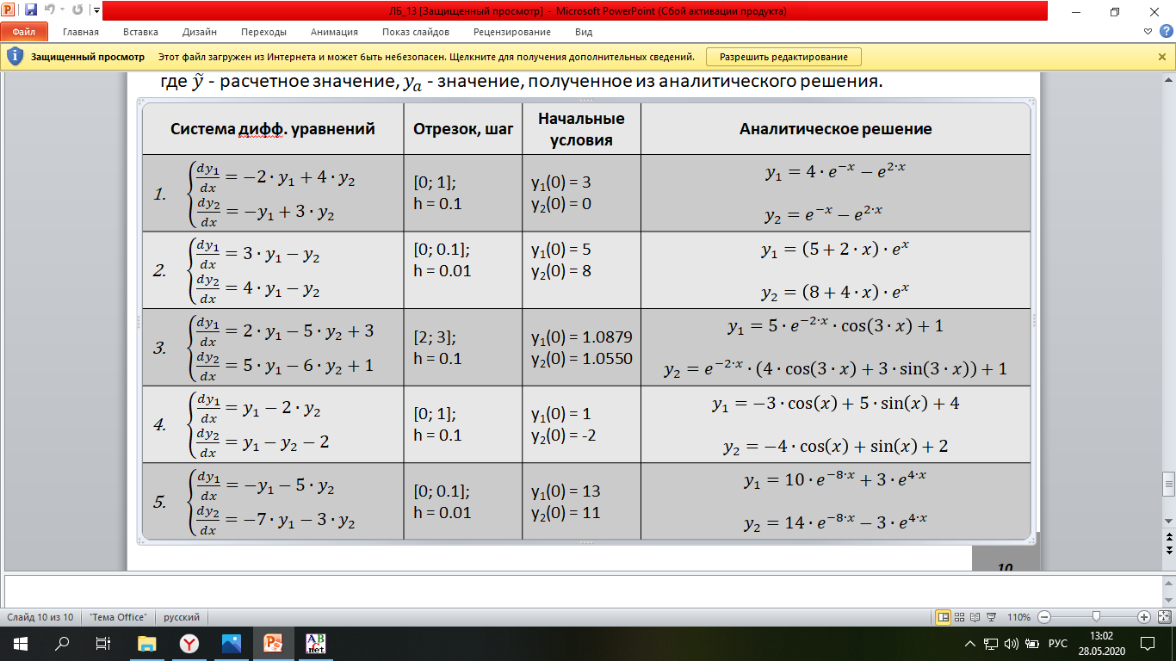

**Программная реализация**

1) Метод Эйлера**:**

program L13_2_1;

type

matrix = array of array of real;

arr = array of real;

function right_parts(x, y1, y2: real): arr;

begin

SetLength(result, 2);

result[0] := 3*y1-y2;

result[1] := 4*y1-y2;

end;

function eyler_method(start_x, stop_x, h, start_y1, start_y2: real): matrix;

var

i: integer;

x, y1, y2, dy1, dy2, ya1, ya2: real;

f: arr;

begin

SetLength(result, Trunc((stop_x - start_x) / h) + 1);

for i := 0 to High(result) do

SetLength(result[i], 7);

x := start_x;

y1 := start_y1;

y2 := start_y2;

for i := 0 to High(result) do

begin

result[i, 0] := x;

result[i, 1] := y1;

result[i, 2] := y2;

result[i, 3] := ya1;

result[i, 4] := ya2;

result[i, 5] := dy1;

result[i, 6] := dy2;

f := right_parts(x, y1, y2);

y1 := y1 + h * f[0];

y2 := y2 + h * f[1];

x := x + h;

ya1 := (5+2*x)*exp(x);

ya2 := (8+4*x)*exp(x);

dy1 := abs((y1-ya1)/(ya1))*100;

dy2 := abs((y2-ya2)/(ya2))*100

end;

end;

procedure print_results(res: matrix);

var

i, j: integer;

begin

for i := 0 to High(res) do

begin

for j := 0 to High(res[i]) do

write(res[i, j]:10:4);

writeln

end;

end;

begin

writeln('Х':8,'Y1':10,'Y2':11,'Y1a':10,'Y2a':9,'dY1':11,'dY2':10);

print_results(eyler_method(0, 0.1, 0.01, 5, 8))

end.

**Ответ**

Х Y1 Y2 Y1a Y2a dY1 dY2

0.0000 5.0000 8.0000 0.0000 0.0000 0.0000 0.0000

0.0100 5.0700 8.1200 5.0705 8.1208 0.0089 0.0099

0.0200 5.1409 8.2416 5.1418 8.2432 0.0178 0.0197

0.0300 5.2127 8.3648 5.2141 8.3673 0.0266 0.0295

0.0400 5.2854 8.4897 5.2873 8.4930 0.0355 0.0393

0.0500 5.3591 8.6162 5.3615 8.6204 0.0442 0.0490

0.0600 5.4337 8.7444 5.4366 8.7495 0.0530 0.0586

0.0700 5.5093 8.8743 5.5127 8.8804 0.0617 0.0682

0.0800 5.5858 9.0059 5.5898 9.0129 0.0704 0.0778

0.0900 5.6633 9.1393 5.6678 9.1473 0.0791 0.0873

0.1000 5.7418 9.2745 5.7469 9.2834 0.0877 0.0968

2) Метод Рунге-Кутты:

program L13_2_2;

type

matrix = array of array of real;

arr = array of real;

function right_parts(x, y1, y2: real): arr;

begin

SetLength(result, 2);

result[0] := 3*y1-y2;

result[1] := 4*y1-y2;

end;

function runge_kutt_method(start_x, stop_x, h, start_y1, start_y2: real): matrix;

var

i: integer;

x, y1, y2, dy1, dy2, ya1, ya2: real;

k1, k2, k3, k4: arr;

begin

SetLength(result, Trunc((stop_x - start_x) / h) + 1);

for i := 0 to High(result) do

SetLength(result[i], 7);

x := start_x;

y1 := start_y1;

y2 := start_y2;

for i := 0 to High(result) do

begin

result[i, 0] := x;

result[i, 1] := y1;

result[i, 2] := y2;

result[i, 3] := ya1;

result[i, 4] := ya2;

result[i, 5] := dy1;

result[i, 6] := dy2;

k1:= right_parts(x, y1, y2);

k2:= right_parts(x + h/2, y1 + k1[0] * h/2, y2 + k1[1] * h / 2);

k3:= right_parts(x + h/2, y1 + k2[0] * h/2, y2 + k2[1] * h / 2);

k4 := right_parts(x + h, y1 + k3[0] * h, y2 + k3[1] * h);

y1 := y1 + h / 6 * (k1[0] + 2 * k2[0] + 2 * k3[0] + k4[0]);

y2 := y2 + h / 6 * (k1[1] + 2 * k2[1] + 2 * k3[1] + k4[1]);

x := x + h;

ya1 := (5+2*x)*exp(x);

ya2 := (8+4*x)*exp(x);

dy1 := abs((y1-ya1)/(ya1))*100;

dy2 := abs((y2-ya2)/(ya2))*100

end;

end;

procedure print_results(res: matrix);

var

i, j: integer;

begin

for i := 0 to High(res) do

begin

for j := 0 to High(res[i]) do

write(res[i, j]:10:4);

writeln

end;

end;

begin

writeln('Х':8,'Y1':10,'Y2':11,'Y1a':10,'Y2a':9,'dY1':11,'dY2':10);

print_results(runge_kutt_method(0, 0.1, 0.01, 5, 8))

end.

**Ответ**

Х Y1 Y2 Y1a Y2a dY1 dY2

0.0000 5.0000 8.0000 0.0000 0.0000 0.0000 0.0000

0.0100 5.0705 8.1208 5.0705 8.1208 0.0000 0.0000

0.0200 5.1418 8.2432 5.1418 8.2432 0.0000 0.0000

0.0300 5.2141 8.3673 5.2141 8.3673 0.0000 0.0000

0.0400 5.2873 8.4930 5.2873 8.4930 0.0000 0.0000

0.0500 5.3615 8.6204 5.3615 8.6204 0.0000 0.0000

0.0600 5.4366 8.7495 5.4366 8.7495 0.0000 0.0000

0.0700 5.5127 8.8804 5.5127 8.8804 0.0000 0.0000

0.0800 5.5898 9.0129 5.5898 9.0129 0.0000 0.0000

0.0900 5.6678 9.1473 5.6678 9.1473 0.0000 0.0000

0.1000 5.7469 9.2834 5.7469 9.2834 0.0000 0.0000

**Задание 3**

**Задание:** решите систему дифференциальных уравнений методами Эйлера и Рунге-Кутты. Определите погрешность расчетного значения переменной y для каждого из методов, использовав формулу:



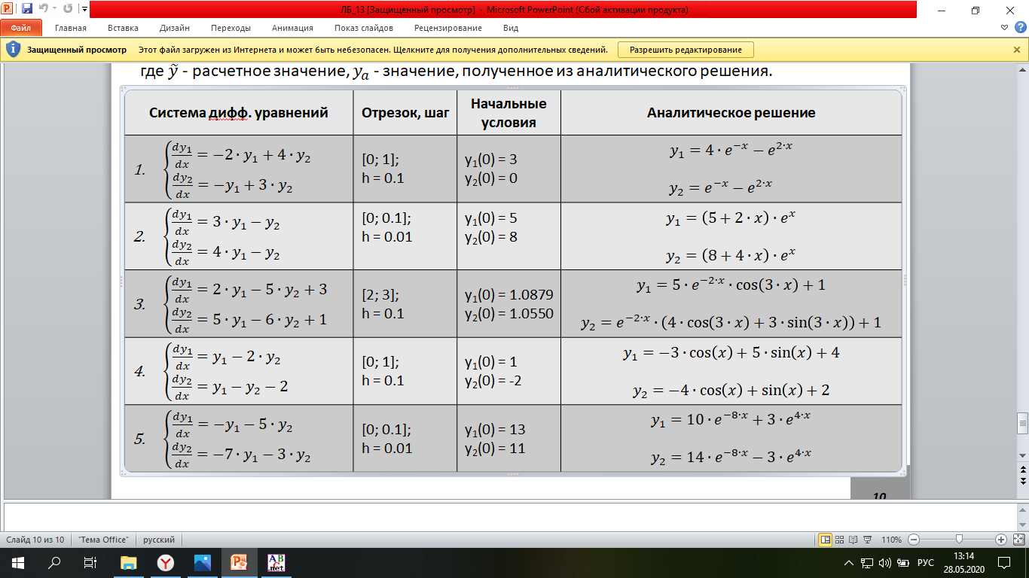

**Программная реализация**

1) Метод Эйлера:

program L13_3_1;

type

matrix = array of array of real;

arr = array of real;

function right_parts(x, y1, y2: real): arr;

begin

SetLength(result, 2);

result[0] := 2*y1-5*y2+3;

result[1] := 5*y1-6*y2+1;

end;

function eyler_method(start_x, stop_x, h, start_y1, start_y2: real): matrix;

var

i: integer;

x, y1, y2, dy1, dy2, ya1, ya2: real;

f: arr;

begin

SetLength(result, Trunc((stop_x - start_x) / h) + 1);

for i := 0 to High(result) do

SetLength(result[i], 7);

x := start_x;

y1 := start_y1;

y2 := start_y2;

for i := 0 to High(result) do

begin

result[i, 0] := x;

result[i, 1] := y1;

result[i, 2] := y2;

result[i, 3] := ya1;

result[i, 4] := ya2;

result[i, 5] := dy1;

result[i, 6] := dy2;

f := right_parts(x, y1, y2);

y1 := y1 + h * f[0];

y2 := y2 + h * f[1];

x := x + h;

ya1 := 5*exp(-2*x)*cos(3*x)+1;

ya2 := exp(-2*x)*(4*cos(3*x)+3*sin(3*x))+1;

dy1 := abs((y1-ya1)/(ya1))*100;

dy2 := abs((y2-ya2)/(ya2))*100

end;

end;

procedure print_results(res: matrix);

var

i, j: integer;

begin

for i := 0 to High(res) do

begin

for j := 0 to High(res[i]) do

write(res[i, j]:10:4);

writeln

end;

end;

begin

writeln('Х':8,'Y1':10,'Y2':11,'Y1a':10,'Y2a':9,'dY1':11,'dY2':10);

print_results(eyler_method(2, 3, 0.1, 1.0879, 1.0550))

end.

**Ответ**

Х Y1 Y2 Y1a Y2a dY1 dY2

2.0000 1.0879 1.0550 0.0000 0.0000 0.0000 0.0000

2.1000 1.0780 1.0660 1.0750 1.0607 0.2803 0.4921

2.2000 1.0606 1.0654 1.0583 1.0581 0.2144 0.6833

2.3000 1.0400 1.0564 1.0410 1.0502 0.0924 0.5910

2.4000 1.0198 1.0426 1.0250 1.0396 0.5086 0.2863

2.5000 1.0025 1.0269 1.0117 1.0283 0.9088 0.1317

2.6000 0.9895 1.0120 1.0015 1.0177 1.1964 0.5595

2.7000 0.9814 0.9996 0.9945 1.0087 1.3175 0.9100

2.8000 0.9779 0.9905 0.9904 1.0018 1.2624 1.1256

2.9000 0.9782 0.9852 0.9887 0.9970 1.0574 1.1834

3.0000 0.9813 0.9832 0.9887 0.9940 0.7515 1.0926

2) Метод Рунге-Кутты:

program L13_3_2;

type

matrix = array of array of real;

arr = array of real;

function right_parts(x, y1, y2: real): arr;

begin

SetLength(result, 2);

result[0] := 2*y1-5*y2+3;

result[1] := 5*y1-6*y2+1;

end;

function runge_kutt_method(start_x, stop_x, h, start_y1, start_y2: real): matrix;

var

i: integer;

x, y1, y2, dy1, dy2, ya1, ya2: real;

k1, k2, k3, k4: arr;

begin

SetLength(result, Trunc((stop_x - start_x) / h) + 1);

for i := 0 to High(result) do

SetLength(result[i], 7);

x := start_x;

y1 := start_y1;

y2 := start_y2;

for i := 0 to High(result) do

begin

result[i, 0] := x;

result[i, 1] := y1;

result[i, 2] := y2;

result[i, 3] := ya1;

result[i, 4] := ya2;

result[i, 5] := dy1;

result[i, 6] := dy2;

k1:= right_parts(x, y1, y2);

k2:= right_parts(x + h/2, y1 + k1[0] * h/2, y2 + k1[1] * h / 2);

k3:= right_parts(x + h/2, y1 + k2[0] * h/2, y2 + k2[1] * h / 2);

k4:= right_parts(x + h, y1 + k3[0] * h, y2 + k3[1] * h);

y1:= y1 + h / 6 * (k1[0] + 2 * k2[0] + 2 * k3[0] + k4[0]);

y2:= y2 + h / 6 * (k1[1] + 2 * k2[1] + 2 * k3[1] + k4[1]);

x := x + h;

ya1 := 5*exp(-2*x)*cos(3*x)+1;

ya2 := exp(-2*x)*(4*cos(3*x)+3*sin(3*x))+1;

dy1 := abs((y1-ya1)/(ya1))*100;

dy2 := abs((y2-ya2)/(ya2))*100

end;

end;

procedure print_results(res: matrix);

var

i, j: integer;

begin

for i := 0 to High(res) do

begin

for j := 0 to High(res[i]) do

write(res[i, j]:10:4);

writeln

end;

end;

begin

writeln('Х':8,'Y1':10,'Y2':11,'Y1a':10,'Y2a':9,'dY1':11,'dY2':10);

print_results(runge_kutt_method(2, 3, 0.1, 1.0879, 1.0550))

end.

**Ответ**

Х Y1 Y2 Y1a Y2a dY1 dY2

2.0000 1.0879 1.0550 0.0000 0.0000 0.0000 0.0000

2.1000 1.0749 1.0607 1.0750 1.0607 0.0033 0.0004

2.2000 1.0583 1.0581 1.0583 1.0581 0.0035 0.0013

2.3000 1.0410 1.0502 1.0410 1.0502 0.0034 0.0019

2.4000 1.0250 1.0396 1.0250 1.0396 0.0032 0.0022

2.5000 1.0117 1.0283 1.0117 1.0283 0.0028 0.0023

2.6000 1.0015 1.0177 1.0015 1.0177 0.0023 0.0023

2.7000 0.9945 1.0087 0.9945 1.0087 0.0017 0.0020

2.8000 0.9904 1.0018 0.9904 1.0018 0.0012 0.0017

2.9000 0.9887 0.9969 0.9887 0.9970 0.0007 0.0014

3.0000 0.9887 0.9940 0.9887 0.9940 0.0003 0.0010

**Задание 4**

**Задание:** решите систему дифференциальных уравнений методами Эйлера и Рунге-Кутты. Определите погрешность расчетного значения переменной y для каждого из методов, использовав формулу:



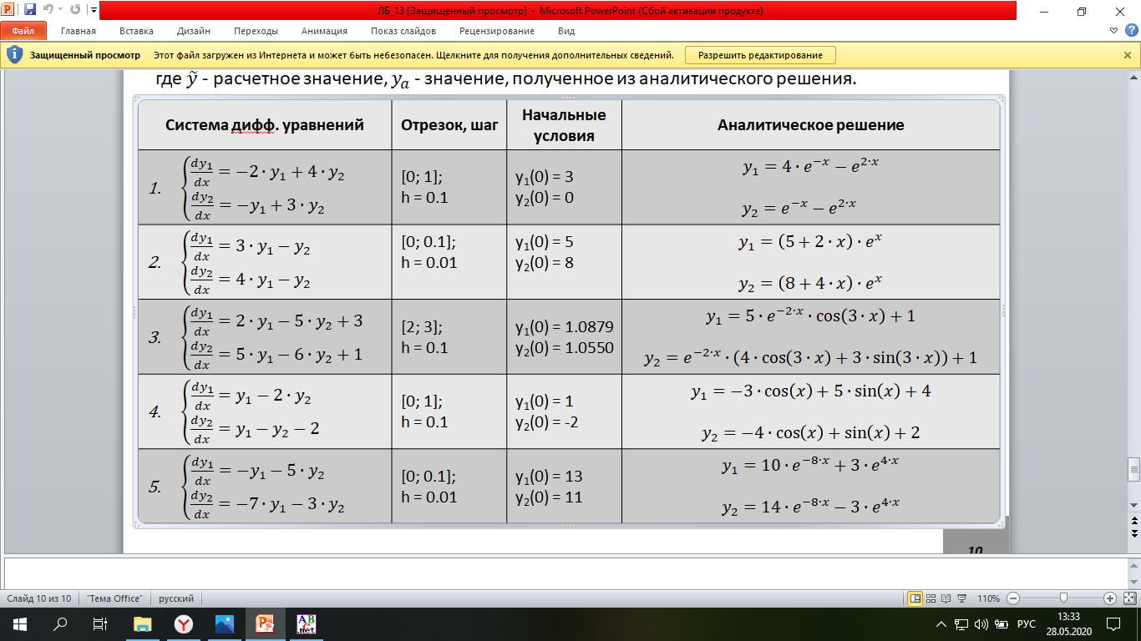

**Программная реализация**

1)Метод Эйлера:

program L13_4_1;

type

matrix = array of array of real;

arr = array of real;

function right_parts(x, y1, y2: real): arr;

begin

SetLength(result, 2);

result[0] := y1-2*y2;

result[1] := y1-y2-2;

end;

function eyler_method(start_x, stop_x, h, start_y1, start_y2: real): matrix;

var

i: integer;

x, y1, y2, dy1, dy2, ya1, ya2: real;

f: arr;

begin

SetLength(result, Trunc((stop_x - start_x) / h) + 1);

for i := 0 to High(result) do

SetLength(result[i], 7);

x := start_x;

y1 := start_y1;

y2 := start_y2;

for i := 0 to High(result) do

begin

result[i, 0] := x;

result[i, 1] := y1;

result[i, 2] := y2;

result[i, 3] := ya1;

result[i, 4] := ya2;

result[i, 5] := dy1;

result[i, 6] := dy2;

f := right_parts(x, y1, y2);

y1 := y1 + h * f[0];

y2 := y2 + h * f[1];

x := x + h;

ya1 := -3*cos(x)+5*sin(x)+4;

ya2 := -4*cos(x)+sin(x)+2;

dy1 := abs((y1-ya1)/(ya1))*100;

dy2 := abs((y2-ya2)/(ya2))*100

end;

end;

procedure print_results(res: matrix);

var

i, j: integer;

begin

for i := 0 to High(res) do

begin

for j := 0 to High(res[i]) do

write(res[i, j]:10:4);

writeln

end;

end;

begin

writeln('Х':8,'Y1':10,'Y2':11,'Y1a':10,'Y2a':9,'dY1':11,'dY2':10);

print_results(eyler_method(0, 1, 0.1, 1, -2))

end.

**Ответ**

Х Y1 Y2 Y1a Y2a dY1 dY2

0.0000 1.0000 -2.0000 0.0000 0.0000 0.0000 0.0000

0.1000 1.5000 -1.9000 1.5142 -1.8802 0.9348 1.0540

0.2000 2.0300 -1.7600 2.0531 -1.7216 1.1274 2.2307

0.3000 2.5850 -1.5810 2.6116 -1.5258 1.0182 3.6160

0.4000 3.1597 -1.3644 3.1839 -1.2948 0.7603 5.3733

0.5000 3.7486 -1.1120 3.7644 -1.0309 0.4205 7.8654

0.6000 4.3458 -0.8259 4.3472 -0.7367 0.0323 12.1129

0.7000 4.9456 -0.5088 4.9266 -0.4152 0.3858 22.5487

0.8000 5.5419 -0.1633 5.4967 -0.0695 0.8227 135.1045

0.9000 6.1287 0.2072 6.0518 0.2969 1.2712 30.2118

1.0000 6.7002 0.5993 6.5864 0.6803 1.7266 11.8948

2) Метод Рунге-Кутты

program L13_4_2;

type

matrix = array of array of real;

arr = array of real;

function right_parts(x, y1, y2: real): arr;

begin

SetLength(result, 2);

result[0] := y1-2*y2;

result[1] := y1-y2-2;

end;

function runge_kutt_method(start_x, stop_x, h, start_y1, start_y2: real): matrix;

var

i: integer;

x, y1, y2, dy1, dy2, ya1, ya2: real;

k1, k2, k3, k4: arr;

begin

SetLength(result, Trunc((stop_x - start_x) / h) + 1);

for i := 0 to High(result) do

SetLength(result[i], 7);

x := start_x;

y1 := start_y1;

y2 := start_y2;

for i := 0 to High(result) do

begin

result[i, 0] := x;

result[i, 1] := y1;

result[i, 2] := y2;

result[i, 3] := ya1;

result[i, 4] := ya2;

result[i, 5] := dy1;

result[i, 6] := dy2;

k1 := right_parts(x, y1, y2);

k2 := right_parts(x + h/2, y1 + k1[0] * h/2, y2 + k1[1] * h / 2);

k3 := right_parts(x + h/2, y1 + k2[0] * h/2, y2 + k2[1] * h / 2);

k4 := right_parts(x + h, y1 + k3[0] * h, y2 + k3[1] * h);

y1 := y1 + h / 6 * (k1[0] + 2 * k2[0] + 2 * k3[0] + k4[0]);

y2 := y2 + h / 6 * (k1[1] + 2 * k2[1] + 2 * k3[1] + k4[1]);

x := x + h;

ya1 := -3*cos(x)+5*sin(x)+4;

ya2 := -4*cos(x)+sin(x)+2;

dy1 := abs((y1-ya1)/(ya1))*100;

dy2 := abs((y2-ya2)/(ya2))*100

end;

end;

procedure print_results(res: matrix);

var

i, j: integer;

begin

for i := 0 to High(res) do

begin

for j := 0 to High(res[i]) do

write(res[i, j]:10:4);

writeln

end;

end;

begin

writeln('Х':8,'Y1':10,'Y2':11,'Y1a':10,'Y2a':9,'dY1':11,'dY2':10);

print_results(runge_kutt_method(0, 1, 0.1, 1, -2))

end.

**Ответ**

Х Y1 Y2 Y1a Y2a dY1 dY2

0.0000 1.0000 -2.0000 0.0000 0.0000 0.0000 0.0000

0.1000 1.5142 -1.8802 1.5142 -1.8802 0.0000 0.0000

0.2000 2.0531 -1.7216 2.0531 -1.7216 0.0000 0.0000

0.3000 2.6116 -1.5258 2.6116 -1.5258 0.0001 0.0000

0.4000 3.1839 -1.2948 3.1839 -1.2948 0.0001 0.0001

0.5000 3.7644 -1.0309 3.7644 -1.0309 0.0001 0.0001

0.6000 4.3472 -0.7367 4.3472 -0.7367 0.0001 0.0002

0.7000 4.9266 -0.4152 4.9266 -0.4152 0.0001 0.0004

0.8000 5.4967 -0.0695 5.4967 -0.0695 0.0001 0.0032

0.9000 6.0518 0.2969 6.0518 0.2969 0.0001 0.0009

1.0000 6.5864 0.6803 6.5864 0.6803 0.0001 0.0005

**Задание 5**

**Задание:** решите систему дифференциальных уравнений методами Эйлера и Рунге-Кутты. Определите погрешность расчетного значения переменной y для каждого из методов, использовав формулу:



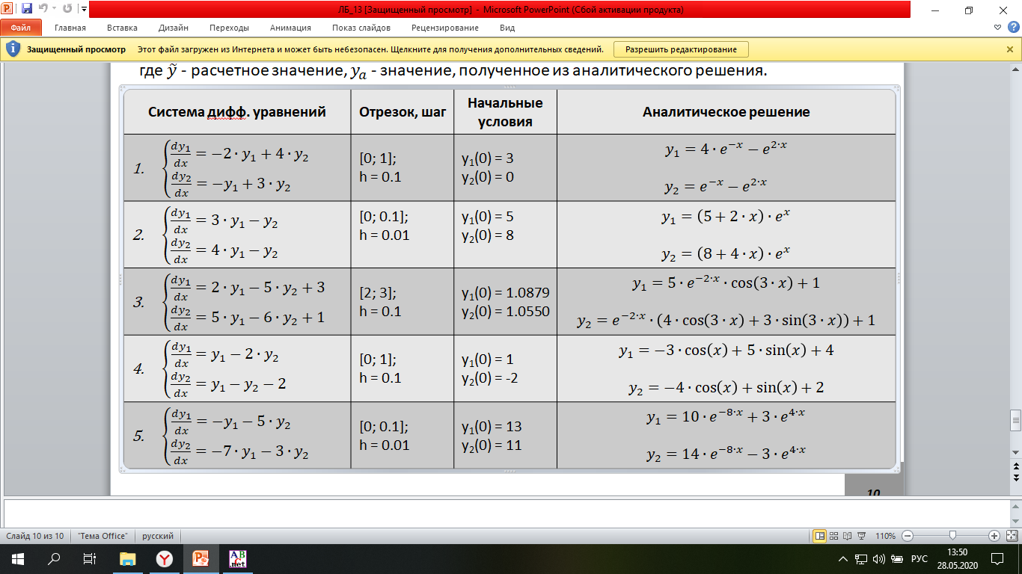

**Программная реализация**

1)Метод Эйлера:

program L13_5_1;

type

matrix = array of array of real;

arr = array of real;

function right_parts(x, y1, y2: real): arr;

begin

SetLength(result, 2);

result[0] := -y1-5*y2;

result[1] := -7*y1-3*y2;

end;

function eyler_method(start_x, stop_x, h, start_y1, start_y2: real): matrix;

var

i: integer;

x, y1, y2, dy1, dy2, ya1, ya2: real;

f: arr;

begin

SetLength(result, Trunc((stop_x - start_x) / h) + 1);

for i := 0 to High(result) do

SetLength(result[i], 7);

x := start_x;

y1 := start_y1;

y2 := start_y2;

for i := 0 to High(result) do

begin

result[i, 0] := x;

result[i, 1] := y1;

result[i, 2] := y2;

result[i, 3] := ya1;

result[i, 4] := ya2;

result[i, 5] := dy1;

result[i, 6] := dy2;

f := right_parts(x, y1, y2);

y1 := y1 + h * f[0];

y2 := y2 + h * f[1];

x := x + h;

ya1 := 10*exp(-8*x)+3*exp(4*x);

ya2 := 14*exp(-8*x)-3*exp(4*x);

dy1 := abs((y1-ya1)/(ya1))*100;

dy2 := abs((y2-ya2)/(ya2))*100

end;

end;

procedure print_results(res: matrix);

var

i, j: integer;

begin

for i := 0 to High(res) do

begin

for j := 0 to High(res[i]) do

write(res[i, j]:10:4);

writeln

end;

end;

begin

writeln('Х':8,'Y1':10,'Y2':11,'Y1a':10,'Y2a':9,'dY1':11,'dY2':10);

print_results(eyler_method(0, 0.1, 0.01, 13, 11))

end.

**Ответ**

Х Y1 Y2 Y1a Y2a dY1 dY2

0.0000 13.0000 11.0000 0.0000 0.0000 0.0000 0.0000

0.0100 12.3200 9.7600 12.3536 9.8012 0.2720 0.4203

0.0200 11.7088 8.6048 11.7713 8.6802 0.5309 0.8681

0.0300 11.1615 7.5270 11.2488 7.6303 0.7761 1.3533

0.0400 10.6735 6.5199 10.7820 6.6456 1.0065 1.8904

0.0500 10.2408 5.5772 10.3674 5.7203 1.2215 2.5014

0.0600 9.8595 4.6930 10.0016 4.8492 1.4205 3.2213

0.0700 9.5263 3.8621 9.6815 4.0275 1.6033 4.1087

0.0800 9.2379 3.0794 9.4043 3.2507 1.7695 5.2713

0.0900 8.9915 2.3403 9.1675 2.5145 1.9194 6.9285

0.1000 8.7846 1.6407 8.9688 1.8151 2.0532 9.6095

2) Метод Рунге-Кутты

program L13_5_2;

type

matrix = array of array of real;

arr = array of real;

function right_parts(x, y1, y2: real): arr;

begin

SetLength(result, 2);

result[0] := -y1-5*y2;

result[1] := -7*y1-3*y2;

end;

function runge_kutt_method(start_x, stop_x, h, start_y1, start_y2: real): matrix;

var

i: integer;

x, y1, y2, dy1, dy2, ya1, ya2: real;

k1, k2, k3, k4: arr;

begin

SetLength(result, Trunc((stop_x - start_x) / h) + 1);

for i := 0 to High(result) do

SetLength(result[i], 7);

x := start_x;

y1 := start_y1;

y2 := start_y2;

for i := 0 to High(result) do

begin

result[i, 0] := x;

result[i, 1] := y1;

result[i, 2] := y2;

result[i, 3] := ya1;

result[i, 4] := ya2;

result[i, 5] := dy1;

result[i, 6] := dy2;

k1 := right_parts(x, y1, y2);

k2 := right_parts(x + h/2, y1 + k1[0] * h/2, y2 + k1[1] * h / 2);

k3 := right_parts(x + h/2, y1 + k2[0] * h/2, y2 + k2[1] * h / 2);

k4 := right_parts(x + h, y1 + k3[0] * h, y2 + k3[1] * h);

y1 := y1 + h / 6 * (k1[0] + 2 * k2[0] + 2 * k3[0] + k4[0]);

y2 := y2 + h / 6 * (k1[1] + 2 * k2[1] + 2 * k3[1] + k4[1]);

x := x + h;

ya1 := 10*exp(-8*x)+3*exp(4*x);

ya2 := 14*exp(-8*x)-3*exp(4*x);

dy1 := abs((y1-ya1)/(ya1))*100;

dy2 := abs((y2-ya2)/(ya2))*100

end;

end;

procedure print_results(res: matrix);

var

i, j: integer;

begin

for i := 0 to High(res) do

begin

for j := 0 to High(res[i]) do

write(res[i, j]:10:4);

writeln

end;

end;

begin

writeln('Х':8,'Y1':10,'Y2':11,'Y1a':10,'Y2a':9,'dY1':11,'dY2':10);

print_results(runge_kutt_method(0, 0.1, 0.01, 13, 11))

end.

**Ответ**

Х Y1 Y2 Y1a Y2a dY1 dY2

0.0000 13.0000 11.0000 0.0000 0.0000 0.0000 0.0000

0.0100 12.3536 9.8012 12.3536 9.8012 0.0000 0.0000

0.0200 11.7713 8.6802 11.7713 8.6802 0.0000 0.0000

0.0300 11.2488 7.6303 11.2488 7.6303 0.0000 0.0000

0.0400 10.7820 6.6456 10.7820 6.6456 0.0000 0.0000

0.0500 10.3674 5.7203 10.3674 5.7203 0.0000 0.0000

0.0600 10.0016 4.8492 10.0016 4.8492 0.0000 0.0000

0.0700 9.6815 4.0275 9.6815 4.0275 0.0000 0.0000

0.0800 9.4043 3.2507 9.4043 3.2507 0.0000 0.0001

0.0900 9.1675 2.5145 9.1675 2.5145 0.0000 0.0001

0.1000 8.9688 1.8151 8.9688 1.8151 0.0000 0.0001

**Выводы**

В ходе работы были изучены и использованы метод Эйлера и Рунге-Кутты для решения систем обыкновенных дифференциальных уравнений.